Human space. Population.
3rd year of ESO (Compulsory Secondary Education)

1. Spatial distribution of the world population
1.1 Population and demographic sources
Population: It is the set of inhabitants of a territory.
Geography: The science that studies the distribution, evolution, movements, and structure of populations in space.
Related sciences: Demography, sociology, and economics also deal with its study.
Information sources: Data necessary for the analysis. The most comprehensive sources are those of the UN Population Division.
1.2 The unequal distribution of the population
Total population: In 2021, the Earth had 7.837 billion people.
Population density: The ratio between the number of inhabitants and the area of the territory (inhabitants/km²). It is used to analyze uneven distribution.
Focus of concentration:
Main areas: South and Southeast Asia, Western and Central Europe, and the East Coast of the USA.
Others: Nile Valley, coastlines (Brazil, Mexico, Maghreb) and areas with mineral resources.
Depopulation hotspots: Cold areas (dust), high mountains (Himalayas, Rockies), deserts (Sahara, Australia) and large equatorial rainforests.
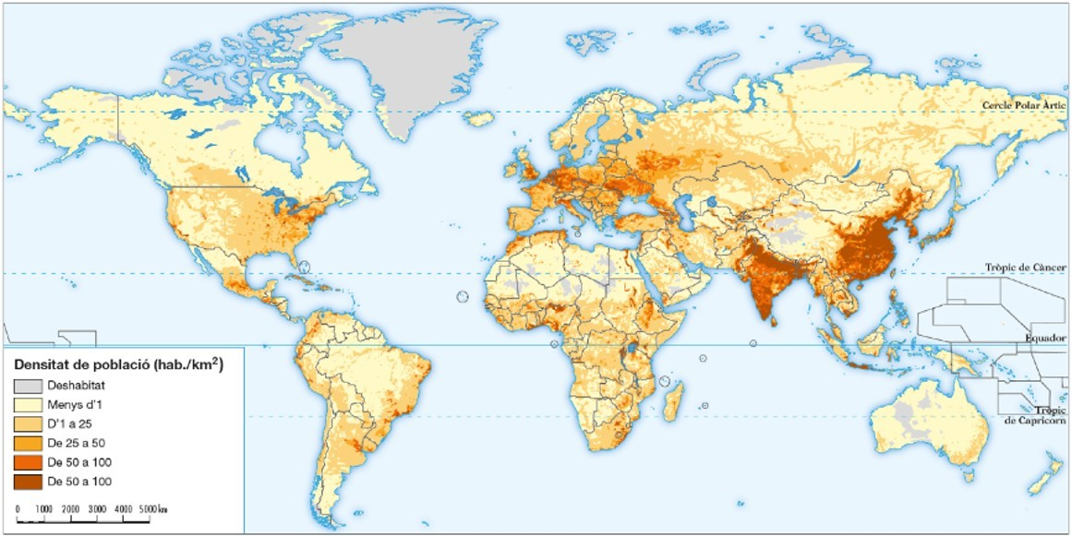

1.3 Distribution factors
Physical factors: These influence settlement patterns. Flat terrain, temperate climates, proximity to the sea, availability of fresh water, and fertile soils are preferred.
Human factors:
Historical factors: The antiquity of settlement explains the high densities in Asia and Europe.
Political: State decisions, wars, or border changes that cause vacuums or concentrations.
Economic factors: In agrarian societies, fertile soil is sought; in industrial and service societies, cities, ports, and mining basins are preferred.
1.4. The distribution of the European and Spanish population
Europe: Uneven. Focus on the European Diagonal (UK-Italy) and its coastlines. Empty spaces in cold areas (North/Russia) and mountains.
Spain: Average density (93.7 inhabitants /km²).
Concentration: Madrid, peninsular periphery and islands (commerce and tourism).
Depopulation: Peninsular interior and mountains (rural exodus).
2. Natural population movements
2.1 Population dynamism
Natural movement (Vegetative): It is the difference between birth and death rates.
Migration movements: Spatial displacements of people.
Immigration: Arrival of population (sum).
Emigration: Exit of population (remainder).
Measurement: Indices called rates are used, which are normally expressed in per thousand (‰).
2.2 Birth rate
Definition: Number of births in a population during a year.
Indicators: Birth rate and fertility rate (children per woman).
Spatial differences (2020 data): World: 18‰ (low). Fertility: 2.3.
Uncooperative countries: Low birth rate.
Less developed countries: High birth rate.
Explanatory factors:
Biological: Mother's age.
Socioeconomic factors: Cost of children, women's work, use of contraceptives, or religion.
Politicians: Aid to families or laws on family planning.
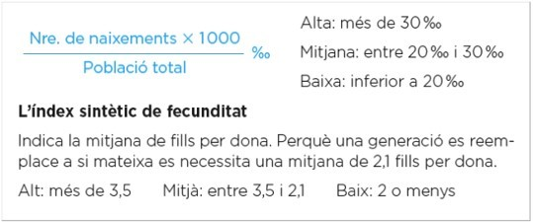

2.3 Mortality
Definition: Number of deaths in a population during a year.
Indicators: Mortality rate, infant mortality rate, and life expectancy.
Spatial differences (2020 data):
World average: 8‰ (low).
Uncoiled countries: It rises due to the aging of the population.
Less uninvolved countries: Tends to decrease thanks to improvements in healthcare.
Explanatory factors:
Biological factors: Heredity and sex (women tend to live longer).
Socioeconomic factors: Diet, income, lifestyle habits, and cultural level.
Politicians: Access to drinking water, sanitation and health system (State of well-being).
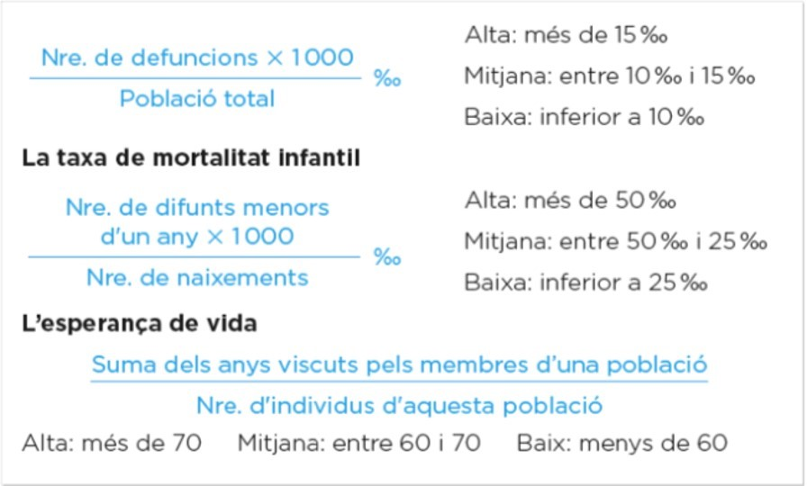
2.4. The European and Spanish natural movement
Model: Modern demographic regime (low birth and death rates).
Europe: Weak or negative growth. The West and North are faring better due to pro-natalist policies; the East is losing population.
Spain: Transition ended in 1975. Minimal birth rate (instability, delayed motherhood) and low mortality, but growing due to aging.
3. Natural growth and evolution of the world population
3.1 Natural growth and its differences
Definition: Difference between birth rate and death rate.
Positive: Births > Deaths.
Negative: Deaths > Births.
Current contrasts:
Highly developed countries: Weak or negative growth (mortality may exceed birth rate).
Low development countries: High growth (high birth rate and declining mortality).
Real growth: Natural growth + net migration.

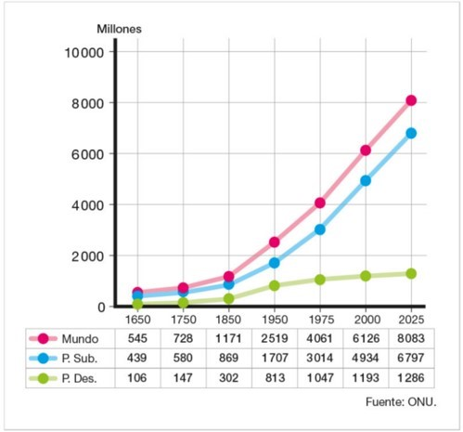
3.2 The theory of demographic transition (Y)
It establishes the stages that the population goes through:
Old demographic regime (Until 1750):
Birth rate: Very high (no contraceptives, children needed to work).
Mortality: Very high (poor diet, medicine and hygiene).
Result: Low life expectancy (33-35 years) and weak growth.
Demographic transition (Fort growth, 1750-1950):
Phase 1: Birth rates remain high, but mortality rates drop rapidly (medical improvements and hygiene). Growth is very high.
Phase 2: The birth rate begins to decline (birth control, urban life). The death rate continues to decline. Growth is positive but slower.

3.3 The theory of demographic transition (II)
Evolution by country:
Unrolled: They completed the transition between 1750 and 1950.
Underdeveloped: They entered the first phase between 1950 and 1975 (population explosion). Currently, emerging countries are already in the second phase.
Modern demographic regime (Since 1950):
Birth rate: Very low (contraceptives, delayed motherhood, cost of raising children).
Mortality: Very low (good medicine and nutrition).
Result: High life expectancy (+70 years) and reduced growth.
Trend: A slowdown in long-term global growth is expected .
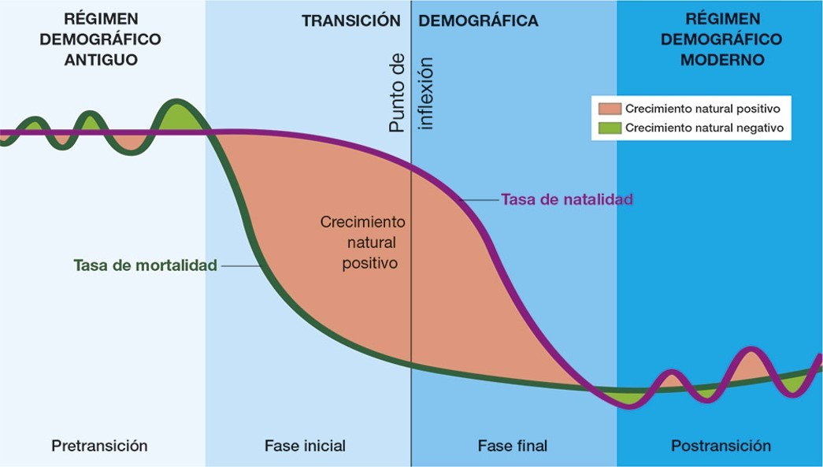

3.4. The growth of the European and Spanish population
Evolution:
Europe: Historical growth from 1750 to 1950 due to the demographic transition; today stagnant and dependent on immigration.
Spain: Similar pace but delayed (demographic transition begins in 1950). Great boom (2000-2008) due to immigration, slowed by the economic crisis.
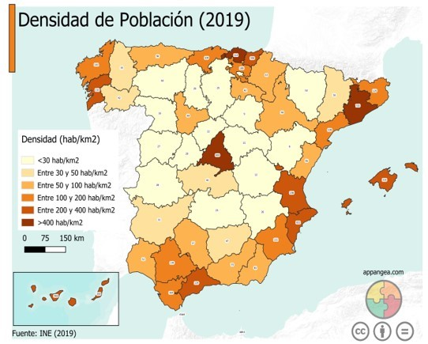

3.5. The population of the Valencian Community
Population: 4th largest in Spain and very dense (217 inhabitants /km²). Concentrated on the coast.
Movements: Negative natural growth. Important historical recipient of national (1960s) and foreign immigration (3rd position in Spain).
Structure: Aging population and economy based on the tertiary sector (services and tourism).
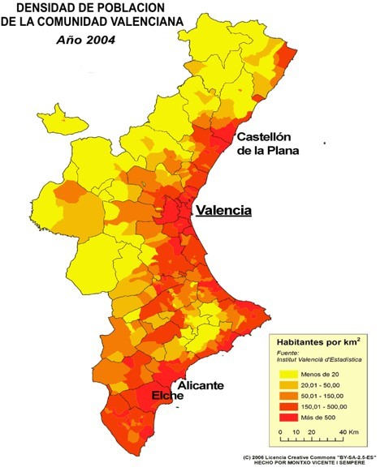

4. The composition of the population
4.1 Composition by sex
Definition: It is the ratio between men and women. It is measured using masculinity and femininity rates.
Global situation (2022): 101.6 men for every 100 women.
Age distribution:
Young people: Males predominate (more males are born).
Elderly: Women predominate (longer life expectancy).
Causes of female longevity: Less risky jobs (traditionally), less participation in wars, and healthier lifestyle habits.
4.2 Age composition
It is divided into three groups: young (0-14), adults (15-64) and elderly (65+).
Predominantly young population: Typical of less developed countries (Sub-Saharan Africa, Asia, Latin America ).
Problems: Malnutrition, illiteracy, and unemployment. It encourages emigration.
Predominantly adult population: Typical of emerging countries.
Advantage: Moderate growth and abundant labor.
Predominantly elderly population: Typical of rich countries (Europe, the USA, Japan).
Problems: Shortage of workers and high expenses in pensions and health.
4.3 Age pyramids
What is it?: A graph that represents the population structure by sex and age at a given time.
What does it tell us?: The degree of youth, maturity or old age of a society.
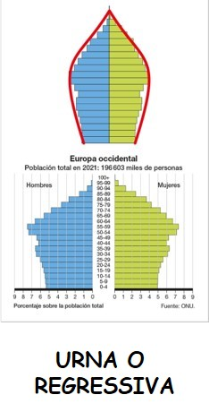
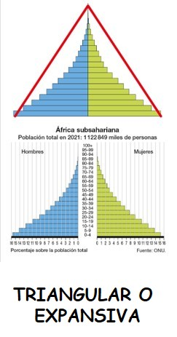
Its recent history: wars, migratory movements, or birth control policies.
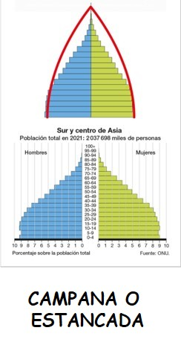

4.4. The composition or structure of the population in Europe and Spain
Biological: Very aged population. High life expectancy (more elderly women) and very few births.
Economic:
Outsourcing: Absolute dominance of the service sector.
Activity: The primary and secondary sectors are losing ground due to technology (they need fewer workers). Massive incorporation of women into the workforce, contraceptives, less influential religious values, etc.

5. Migration movements. Internal migrations
5.1 Migration and migrants
Key concepts:
Emigration: The departure of people from their place of origin.
Immigration: Arrival of population at the destination.
Net migration: Difference between immigration and emigration (can be positive or negative).
Migrant profile:
Entry: Legal (with permission), illegal ("without papers") or refugees (life threatened).
Rating: From low-skilled people (hard jobs) to highly skilled people (specialized tasks).

5.2 The causes of migration
Repulsion (Origin):
Natural: Earthquakes, droughts or floods.
Political: Wars and persecutions (religious, racial or political).
Economic factors: Lack of work, overpopulation, and lack of services.
Attraction (Destination):
Natural: Favorable climate and physical conditions.
Politicians: Social Pau.
Economic: Job offers and social/cultural opportunities.

5.3 Internal migrations
Displacements within the same State. The most prominent is the rural exodus (from the countryside to the city).
In the past (Unrolled countries):
Cause: Mechanization of agriculture and the rise of industry.
Effect: Rural depopulation and urban growth.
Currently (Less uninhibited countries):
Cause: Poor living conditions in the countryside and high population growth.
Effect: Accelerated urban growth, lack of housing/services, poverty and marginalization.

5.4. Migration movements to Europe
Historical (19th-20th centuries): Europe was a country of emigration. Rural exodus and 50 million people moved to America/Oceania.
Recent: Europe is a recipient.
Intra-European : From the South and East to the Center and North for work (former USSR).
Foreigners: Mass immigration (1985-2008) from Africa, Asia, and the Americas. They contribute labor and multiculturalism.

6. Migration movements. External migrations
6.1 Current international migrations
Volume (2020): 280 million people.
Causes: Economic imbalance between richer and poorer countries, impact of cheaper media and transport.
Type of flows:
South-North: Traditionally the most numerous (from less liberal countries to liberal ones like Europe or the USA).
South-South: Experiencing significant growth. Destinations in emerging countries with oil (Persian Gulf) or dynamic economies (Singapore, Malaysia) stand out.
North-South: Humanitarian or economic cooperation.
North-North: Highly qualified people looking for better places.
Refugees: Increasing, concentrated mainly in Asia and Africa.

6.2 International migration policies
In the destination countries:
They regulate entry and working conditions.
Integration: They advocate for multiculturalism or naturalization (obtaining citizenship).
They facilitate the return to the country of origin.
In the countries of origin:
In favor: Some states promote it to reduce unemployment and receive remittances (money sent by emigrants to their families in the country of origin).
On the other hand: Other states are trying to curb it by improving education and local employment to prevent population loss.
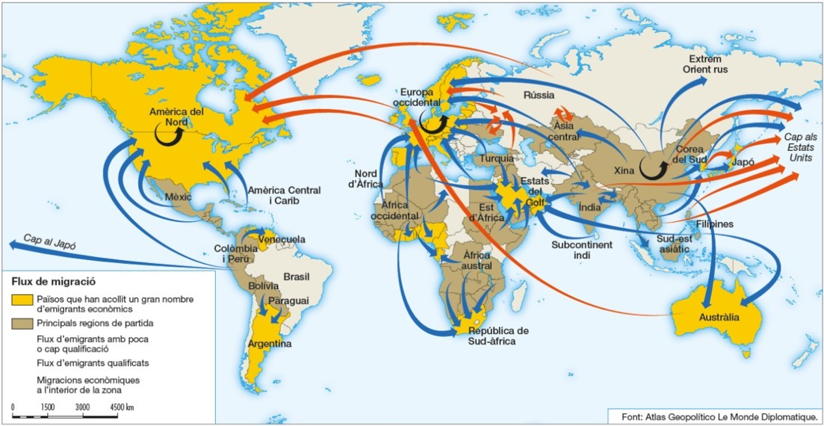

6.3. Migration movements in Spain

Emigration (until 1975): Rural exodus towards Madrid, Catalonia, Basque Country (industrialized and coastal areas) and departures to Europe and Latin America in 1960, which involved sending remittances.
Immigration (since 1995): Large arrival of foreigners (5.4 million in 2021).
Origin: EU (retirees/businesses) and developing countries (manual labor).
Destinations: Madrid, Mediterranean and Canary Islands.

7. The consequences of migration
7.1 The areas of origin
Advantages:
Demographics: Decrease in birth rate and population pressure.
Economic: Remittance income (money sent by emigrants) that helps development and modernization.
Social: Reduction of unemployment and social conflict.
Disadvantages:
Loss of the youngest, most educated and entrepreneurial population.
Aging of the remaining population.
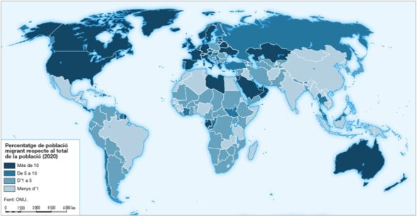

7.2 The destination areas
Advantages:
Demographics: Population increase and rejuvenation (birth rate rises).
Economic: Arrival of labor for the hardest jobs.
Social: Greater cultural, linguistic and religious diversity (multiculturalism).
Disadvantages:
Problems of coexistence: Emergence of negative attitudes such as xenophobia (rejection of foreigners) or racism.
Maladjustment: Difficulty some immigrants have in fitting into new customs.
Services: Shortage of affordable housing and increased pressure on hospitals and schools.

7.3 International cooperation
World Forum on Migration and Development (UN): More than 150 states participate.
Main objectives:
Protect the human and labor rights of migrants.
Avoid xenophobia.
Fight against human trafficking.
Protect refugees and displaced persons due to wars or natural disasters.

8. The future of the world's population
8.1 Population and fertility
Projections (UN): It is estimated that the population will reach 9.6 billion in 2050 and 10.9 billion in 2100.
Uneven growth: 88.2% of the world's population will live in low-development countries by 2100. The areas of greatest growth will be Africa (Nigeria, Congo) and Asia (India, Pakistan).
Decreased fertility:
Uncooperative countries: Growth will be slight due to immigration and birth incentives.
Less developed countries: It will fall from 2.1 children per woman (the rate needed for generational replacement) due to control policies.

8.2 Life expectancy and aging
Life expectancy: The global average will rise to 75.9 years by 2050. The biggest increase will be in poor countries as diseases decrease.
Global aging: It will affect the whole world due to lower birth rates and greater longevity.
Uncoiled countries: Intense aging that threatens pensions and the lack of workers.
Low-income countries: Although there will be an aging population, they will have a large working-age population, which can improve their economy if they invest in health and education.

8.3 Migration and cities
Mass urbanization: The rural exodus will continue to grow. By 2050, 72% of humanity will live in cities.
Urban risks: Environmental problems, lack of food and shortage of drinking water.
International migrations: These are difficult to predict, as they depend on economic and political changes and environmental disasters.
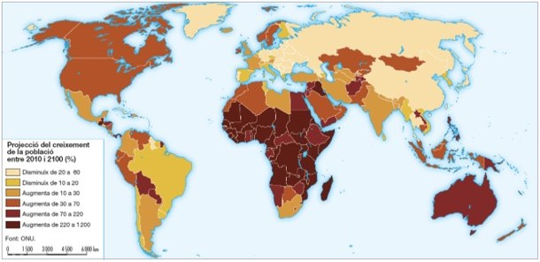

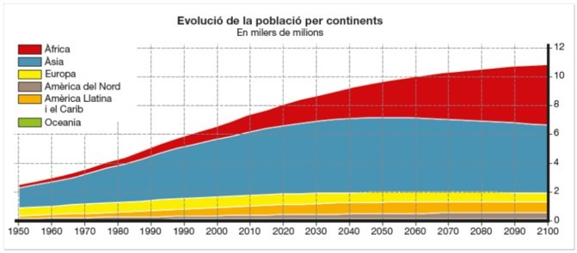

QUESTIONS

1. Spatial distribution of the world population
1.1 Population and demographic sources
→ What is meant by population and what sciences and sources are used to study its distribution?
1.2 The unequal distribution of the population
→ Why is the world's population distributed unevenly and what are the main areas of concentration and depopulation?
1.3 Distribution factors
→ Explain what physical and human factors influence population distribution and give some examples.
1.4 The distribution of the European and Spanish population
→ How is the population distributed in Europe and in Spain, and which areas show greater concentration and depopulation?

2. Natural population movements
2.1 Population dynamics
→ What is the natural movement of the population and what is the difference between immigration and emigration?
2.2 Birth rate
→ What is the birth rate and what factors explain the differences between developed and less developed countries?
2.3 Mortality
→ What indicators are used to measure mortality and why does it vary between more developed and less developed countries?
2.4 The natural movement of the population in Europe and Spain
→ What is the current natural movement of the population to Europe and in Spain, and what are its main causes?

3. Natural growth and evolution of the world population
3.1 Natural growth and its differences
→ What is natural growth and why is it different in developed countries and in underdeveloped countries?
3.2 The theory of demographic transition (Y)
→ Describes the characteristics of the old demographic regime and the two phases of the demographic transition.
3.3 The theory of demographic transition (II)
→ How does the demographic transition apply to developed and less developed countries, and what characterizes the modern demographic regime?
3.4 The growth of the European and Spanish population
→ Explain how population growth has evolved in Europe and in Spain in recent decades.
3.5 The population of the Valencian Community
→ Describe the main demographic characteristics of the population of the Valencian Community.

4. The composition of the population
4.1 Sex composition
→ What is sex composition and why are there more women in older age groups?
4.2 Age composition
→ Explain the three main age groups of the population and the problems or advantages of each one.
4.3 Age pyramids
→ What is a population pyramid and what information does it allow us to know about a society?
4.4 The composition of the population in Europe and Spain
→ What is the current biological and economic structure of the population in Europe and Spain?

5. Migration movements. Internal migrations
5.1 Migrations and migrants
→ Define emigration, immigration and net migration, and describe the current profile of the migrant.
5.2 The causes of migrations
→ Explain the causes of repulsion and attraction that cause migrations.
5.3 Internal migrations
→ What are internal migrations and what are the consequences of rural exodus in developed and less developed countries?
5.4 Migration movements to Europe
→ Describe the historical and current evolution of migrations to Europe.

6. Migration movements. External migrations
6.1 Current international migrations
→ What are the main characteristics and types of international migrations today?
6.2 International migration policies
→ Explain what measures are taken by countries of origin and destination in response to migration.
6.3 Migration movements in Spain
→ Describe the evolution of emigration and immigration in Spain from the 20th century to today.

7. The consequences of migration
7.1 The areas of origin
→ What advantages and disadvantages do migrations have for the countries of origin?
7.2 Destination areas
→ Explain the positive and negative consequences of migration to destination countries.
7.3 International cooperation
→ What objectives does international cooperation in the field of migration pursue?

8. The future of the world's population
8.1 Population and fertility
→ How are world population and fertility expected to evolve in the coming decades?
8.2 Life expectancy and aging
→ Explain how life expectancy and aging will evolve and what problems they may generate.
8.3 Migration and Cities
→ What is the relationship between urbanization, migration, and the problems of large cities in the future?

